

New Century Wellness Group

Business Plan



April 27, 2023

CIT342

Ariann Decker and Camron Sonnie

**Contents**

**New Century Wellness Group** 4

**Background** 4

**Problem Statement** 4

**Audience** 4

**Systems Planning** 5

**Business Profile** 5

**Systems & ERP Questions** 5

**Systems Development Method** 7

**Analyzing the Business Case** 8

**Investigate Steps** 8

***Definitions*** 8

***Investigation Steps*** 8

**Feasibility Types** 9

**Managing Systems Projects** 10

**Tasks** 10

**PERT Chart** 11

**Requirements Modeling** 12

**Interview Summary** 12

**Checklist** 12

**Questionnaire** 13

**Data & Process Modeling** 15

**Context Diagram** 15

**Data Flow Diagram** 16

***Diagram 0 DFD*** 16

**Data Dictionary** 17

**Object Modeling** 18

**Use Case** 18

**Sequence Diagram** 19

**Development Strategies** 20

**Cost Benefit Overview** 20

**Return On Investment (ROI)** 22

**Systems Design** 23

**User Interface Design** 23

**Control Features** 25

**Data Design** 26

**ERD Drawing and Relationships** 26

**Systems Architecture** 27

**Floor Plan Topology** 27

**Physical vs. Logical** 27

**Wireless Network Analysis** 28

**Systems Implementation** 28

**Test Plan** 28

**Training Plan** 29

**Changeover Strategy** 29

# **New Century Wellness Group**

## **Background**

New Century Wellness Group offers a holistic approach to health care with an emphasis on preventative medicine as well as traditional medicinal care. Currently, New Century includes four primary care physicians, one nurse practitioner, four physical therapists, one registered nutritionist, eight nurses, and eight support staff people. The patient base consists of 8,000 patients from 325 different employers and accepts insurance plans from 25 licensed health insurance providers.

## **Problem Statement**

New Century Wellness does not have an efficient system to handle all their data. The new system would be modernized and would be able to support both business and health information management needs. The new system would replace a mix of paper-based and legacy systems. It should be able to allow for employee overseeing, HR and employee benefits, payroll and taxes, reporting, profit distribution, insurance billing, accounts receivable, patient management, organizing and ordering office and medical supplies, and being able to contact patients and schedule appointments.

## **Audience**

This proposal is intended to be viewed by Management responsible for making decisions about the system, like managers and executives. It Staff, those who are responsible for developing, maintaining, and supporting the system. Stakeholders, anyone with a relationship that the system would impact, meaning Customers, Investors, Vendors, etc. This will also be available to view by end users, anyone who will have to interact with the system on a daily basis to handle work duties.

# **Systems Planning**

## **Business Profile**

The mission of New Century Wellness is to connect patients with preventative holistic medicine and traditional medical care, with a focus on fitness. They are the only practice that offers a broad range of services in this field. They currently have one physical location and are contemplating opening another location near a medical center. Found in Figure 1 is a visual representation of the employees and organization within New Century Wellness Group.

**Figure 1**

Visual representation of employees and business organization and hierarchy

## **Systems & ERP Questions**

There are several different types of systems to choose from when creating enterprise applications. Some examples include Transaction Processing System, a Business Support System, and a User Productivity System.

A Transaction Processing System is the data generated by day-to-day tasks. The system is set to perform a series of specific tasks when a transaction occurs. These are typically used to manage large amounts of data and are mission-critical to the system. A Business Support System provides job-related information support to users at all levels of the company. An important feature of this system is its decision support capabilities. It allows users to make decisions by creating a model and applying sets of variables. User Productivity Systems are designed to improve productivity of users by automating tasks and providing tools to collaborate with a team. Enterprise Resource Planning is a software system complete with all the functionality needed to manage and integrate all aspects of running a business. Pictured below in Table 1 and Table 2 are the pros and cons for each system.

**Table 1**

Table illustrating pros and cons of TPS, BSS, UPS.

|  |  |  |
| --- | --- | --- |
| **Transaction Processing System** | **Business Support System** | **User Productivity System** |
| Pros: | Pros: | Pros: |
| Reliable + Less room for Human Error.  Processes transactions quickly and in groups. | Efficient in terms of Operation.  Provides real-time information + improves customer retention. | Time Efficient.  Increased user productivity and increased communication and collaborative efforts. |
| Cons: | Cons: | Cons: |
| Complex to set up and maintain.  Expensive.  Security is vulnerable to breaches. | Timely implementation process.  Requires specialized technical skills.  Expensive. | Requires specialized training.  Vulnerable to security breaches.  Can lead to user dependency. |

**Table 2**

Table illustrating pros and cons of an ERP System.

|  |  |
| --- | --- |
| **Enterprise Resource Planning System** | |
| Pros: | Cons: |
| Efficient. | Complex to implement. |
| Allows for better collaboration. | Requires specialized training. |
| Better Data Management | Expensive to maintain. |

Based on the requirements and constraints of the new system, it is recommended that New Century Wellness choose an ERP system. An ERP system includes all the functionality needed to run a business. It may be costly, but it is combining all separate aspects of various systems and compiling it into one application system. An ERP will support HR functions, inventory, accounting, manage customer information, provide real-time analytics, etc. The benefits of implementing this system far outweigh its cost and negatives.

## **Systems Development Method**

There are three widely used and accepted systems development methods to explore: Structured Analysis, Object-Oriented (O-O) Analysis, and Agile (adaptive) methods. Taking into consideration the deliverables and size of this project, an Agile method would best fit the system. The Agile method is intensely team-based and breaks development down into cycles and runs tests at every level. The benefits of using this development method are its flexibility, deliverables constantly validate project, and it overall reduces risk. Some downsides to this approach are lack of structure and documentation, project subject to scope change, and advanced technical skill and knowledge is needed.

# **Analyzing the Business Case**

## **Investigate Steps**

### ***Definitions***

1. **Electronic Medical Records (EMR) -** Online record of patient medical information that can be accessed by doctors who have authorization to view the information and allow them to manage or change your records to reflect accurate data.
2. **Computerized Provider Order Entry (CPOE) -** Allows providers to send prescriptions and information fast and efficiently without paper.
3. **Clinical Decision Support System (CDSS) -** Allows for reminders and other medical information to be relayed to improve your health.

### ***Investigation Steps***

**Step 1 - Understand the Problem or ­Opportunity:**

* New Century Wellness needs a new computer system to replace their paper records and fragmented computer systems. This is an opportunity to create a system that will house all the records to exist in harmony with the procedures that are already in place.

**Step 2 - Define the Project Scope and Constraints:**

* The new system should support the business and health information management needs of the company. It should allow every office worker to conduct work more efficiently. It should be able to create EMR’s for new patients, allow providers to enter information with the CPOE system, and both the EMR and CPOE are supported by CDSS. It should be able to schedule appointments and allow for review and maintenance of records. The system should also be able to order supplies. It also needs to be able to connect with insurance companies to bill for patient services and allow for reports on billing to make sure the company is getting paid. Additionally, there should be reports for each of these functions. These are necessary for everyday business to be able to occur.
* Constraints: Needs to be able to house a lot of users, needs to connect to EMR, CPOE, and CDSS

**Step 3 - Perform Fact-Finding**:

* Conduct interviews with employees and patients, do a survey, review the information, research medical systems, and observe operations.

**Step 4 - Analyze Project Usability, Cost, Benefit, and Schedule Data:**

* We will weigh the benefits and cost of building a system or buying a system.

**Step 5 - Evaluate Feasibility**

## **Feasibility Types**

There are 4 types of feasibility used when evaluating a system. They are Operational, Technical, Economic, and Schedule feasibility. Operational Feasibility refers to a system being used effectively after it has been developed. Economic feasibility means the proposed benefits of the system outweigh its cost. Technical feasibility refers to technical resources required to develop, install, or operate the system. Schedule feasibility means the proposed system can be implemented in a timely fashion that is within schedule constraints. Below are questions that are relevant when developing this new system.

**Operational** -

* Will patients and providers support the new system?
* Are there legal or ethical issues to be considered?
* Will the new system require extensive training?
* Will it be more efficient?

**Technical** -

* Does the company have the required knowledge to operate the system?
* Does the company have the right hardware and software?
* Will a prototype be created?

**Economic** -

* Will it be out of budget?
* Will it need time and money consuming resources?
* How much does it cost to train employees?
* How much does support cost?

**Schedule** -

* Is there adequate time to complete this project?
* Will there be a project manager?
* What conditions must be satisfied first?
* Is there any fluff time in the schedule to allow for unforeseen events?

# **Managing Systems Projects**

## **Tasks**

A task is any work with a beginning and end and requires use of company resources. Tasks are scheduled and overseen by the project manager. This work is usually manageable and can be done in a short amount of time. They are usually measured in “person days”, which refers to how much work one employee can complete in one day. Located in Figure 2, the proposed tasks for creating the system are laid out.

**Figure 2**

Depicted in the figure below are tasks that must be completed.

## **PERT Chart/ CPM Chart**

The Program Evaluation Review Technique (PERT) was created to manage large complex projects. PERT analyzes the project from the bottom to the top in terms of processes. This was released around the same time as the Critical Path Method (CPM), and now they are referred to as one idea. In Figure 3, a PERT and CPM chart will be displayed.

**Figure 3**

Pert/CPM Chart

# **Requirements Modeling**

## **Interview Summary**

To acquire more information about the system, an interview was conducted. Management, staff members, patients, IT, and stakeholders were involved in the process. The interview aimed to gain information specifically about what they like and dislike about the current system, features they would like to see, and concerns they may have. Based on the information gained from the interviews, a checklist was made for system requirements.

## **Checklist**

The information from the interviews has been displayed graphically in Table 3 to get a better understanding of the system. A system requirement is a characteristic that must be included and are ultimately split up into five categories. The categories are System Outputs, System Inputs, Processes, Performance, and Security.

**Table 3**

A table containing all system requirements for the new proposed system.

|  |  |  |  |  |
| --- | --- | --- | --- | --- |
| **System Outputs** | **System Inputs** | **Process** | **Performance** | **Security** |
| Patients Personal Information:  Name  Address  Phone Number  Birthdate  Insurance Information  Emergency Contact | List of daily appointments | Patient appointments entered into system; list is generated daily. | Capable of managing large amounts of data. | Users and employees should be authenticated upon login. |
| Medical History:  Medications  Vaccinations  Surgeries  Test Results  Appointments | Prescriptions and Insurance Billing. | Typing in the corresponding code for insurance will send a claim for the corresponding treatment. | No lag time, increased speed. | It should have secure communication as well as password requirements. |
| Employee Information:  Name  Address  Phone Number  Title  Payment Information  Work Schedule | Employee paystubs, benefits, 401K, Time off requests | When clocking out, the system will send that data to HR for payroll at the end of the pay period. | Should be reliable and available on all networks. | The system should be able to handle errors without failing or exposing sensitive data. |

## **Questionnaire**

A questionnaire was distributed to every party to promote inclusivity and make sure every group has representation. The survey consisted of range of response questions, open-ended questions, and closed-ended questions. The questions from the survey are documented in the Figures below.

**Figure 4**

**Figure 5**

**Figure 6**

# **Data & Process Modeling**

## **Context Diagram**

A context diagram is a top view approach of looking at the system. It shows the systems boundaries and scope. In the system, Patients, the American Medical Association, Providers, Staff, and health insurance are entities in this system. The data flows include: Patient Inputs, Data Reports and Outputs, Patient Payments, Claims, Health Insurance Payments, Staff Inputs and Outputs, Provider Inputs, Provider Outputs, and CPT Codes Input. A proposed context diagram for the system is demonstrated below.

**Figure 7**

Proposed Context Diagram for NCWG.

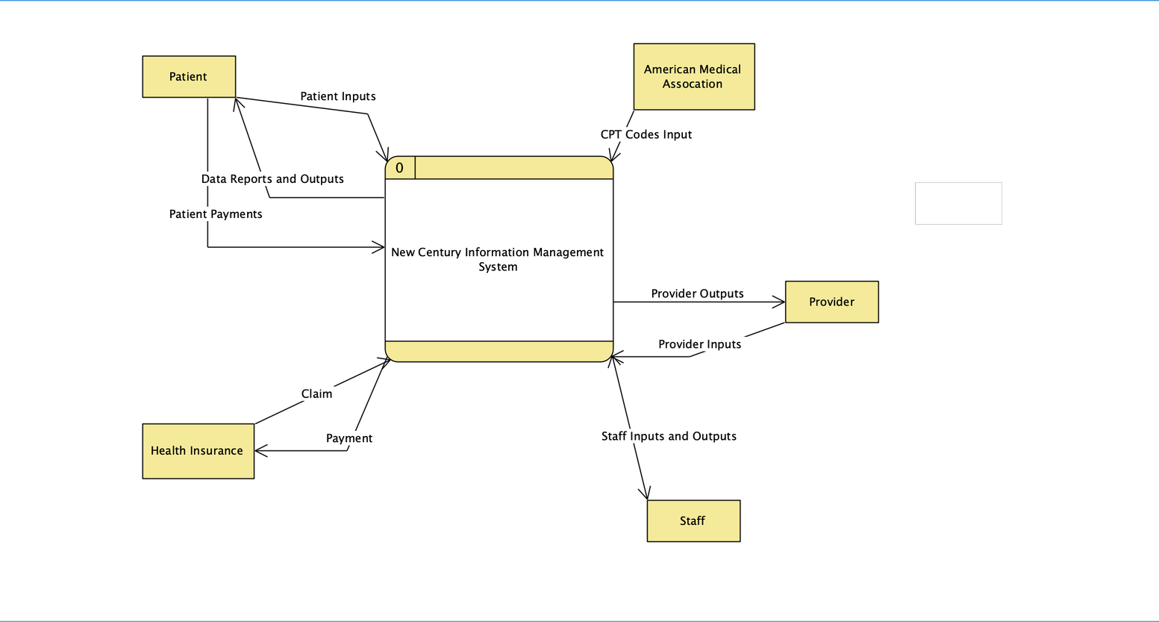

## **Data Flow Diagram**

### ***Diagram 0 DFD***

A diagram 0 is used to provide an overview of all components that interact and form the system as a whole. A diagram 0 expands on the system proposed in a context diagram. Diagram 0’s have entities, data flows, processes, and data stores.

**Figure 8**

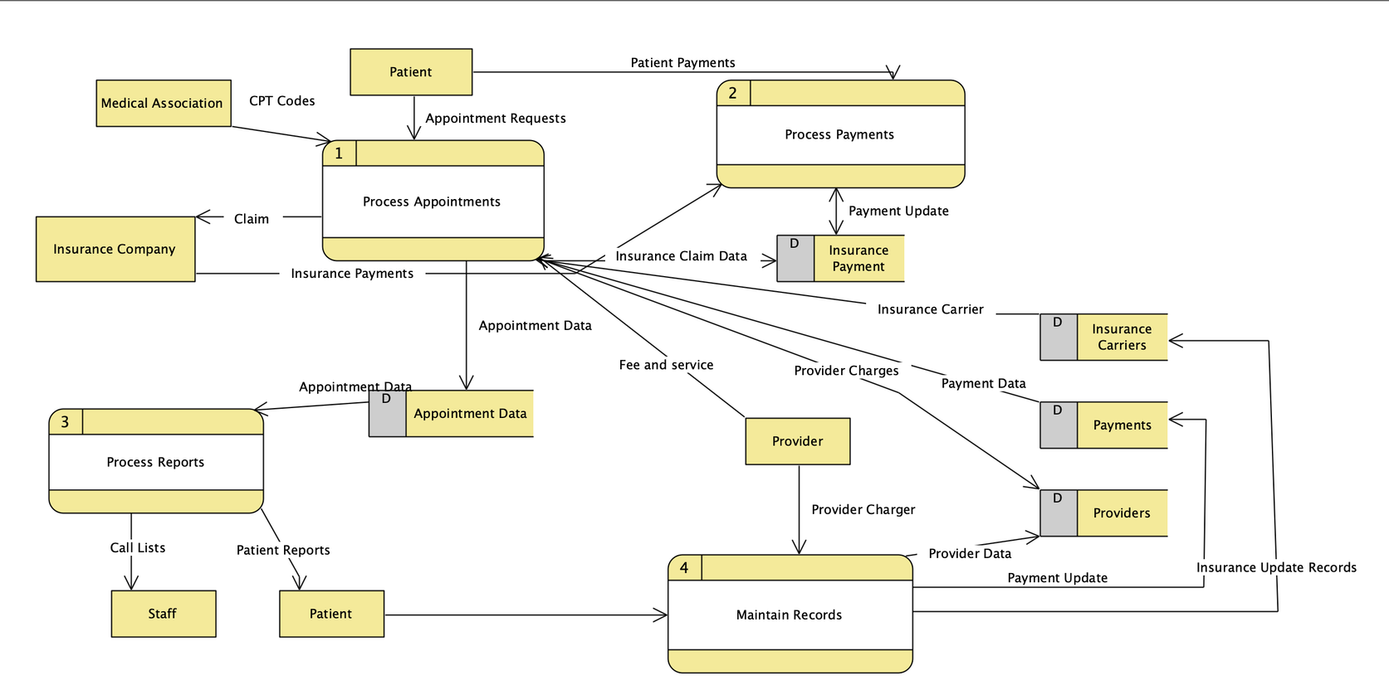Diagram 0 DFD for the NCWG system.

## **Data Dictionary**

**PROCESS MAKE APPOINTMENT**

PURPOSE: Schedules a patient’s appointment and services.

**INPUT DATA FLOWS: APPOINTMENT REQUEST**

PATIENT DATACPT FEE SCHEDULE

**OUTPUT DATA FLOWS: SERVICE DATAAPPT Data PROCESS DESCRIPTION:**

For each APPOINTMENT REQUEST from PATIENT Retrieve PATIENT NUMBER from PATIENTS Verify PATIENT NUMBER For each CPT CODE in APPOINTMENT REQUEST Retrieve CPT CODE from CPT FEE SCHEDULE Add/Change/Delete CPT CODE in SCHEDULED SERVICE DATA Add/Change/Delete PROVIDER NUMBER in SCHEDULED SERVICE DATA Add/Change/Delete APPOINTMENT NUMBER, APPOINTMENT DATE, START TIME, PATIENT NUMBER in SCHEDULED APPOINTMENT DATA

**COMPLETE APPOINTMENT**

PURPOSE: Processes an appointment that has been completed

**INPUT DATA FLOWS: EMPLOYER DATA**

PROVIDER DATAHOUSEHOLD DATASERVICE DATAAPPT DATA

**OUTPUT DATA FLOWS: CLAIM**

CHARGESPROVIDER CHARGESSERVICE CHARGESERVICE DATA

**PROCESS CREATE APPOINTMENT LIST**

PURPOSE: Prepare and print the daily appointment list that shows all patients and their scheduled services for each provider

**INPUT DATA FLOWS: SERVICE DATA**

PROVIDER APPOINTMENT DATA

**OUTPUT DATA FLOWS: APPOINTMENT LIST**

**PROCESS PATIENT PAYMENT**

PURPOSE: Process a payment received from a patient

**INPUT DATA FLOWS: PATIENT PAYMENT**

**OUTPUT DATA FLOWS: MTD PAYMENTS YTD PAYMENTS**

**PROCESS INSURANCE PAYMENT**

PURPOSE: Process a payment received from an insurance company

**INPUT DATA FLOWS: INSURANCE PAYMENT OUTPUT DATA FLOWS: MTD PAYMENTS YTD PAYMENTS**

# **Object Modeling**

## **Use Case**

Boundary: New Century Wellness System

Actors: Customer, Staff, Insurance

Use cases: Appointment request, Appointment Notification, Update, Insurance Claim, Update Records

**Figure 9**

Use Case for NCWG System.

**Sequence Diagram**

Depicted below is a sequence diagram for the system. It presents the interaction with the system vertically and the messages being sent between objects are represented by horizontal arrows.

**Figure 10**

Sequence Diagram of a change appointments use case.

# **Development Strategies**

## **Cost Benefit Overview**

Pictured below is a cost benefit analysis. It can be used to examine the feasibility of each item to see if it is positively or negatively affecting the business’ revenue. In Table 4, the information at hand was evaluated along with its financial impact.

**Table 4**

Cost Benefit Analysis

|  |  |  |
| --- | --- | --- |
| ***Cost or Benefit*** | ***Financial Impact*** | ***Description of Cost or Benefit*** |
| *Eliminate three hours of overtime each week at $15 per hour* | *Save $45 a week* | *Operational* |
| *Eliminate need for additional position in six months* | 40 hours | *Operational, Direct* |
| *Eliminate daily errors* | *Six months of impact* | *Direct, Operational* |
| *For in-house option: consultant’s time to develop system* | *$2500* | *Developmental* |
| *For in-house option: networked commercial database software for in-house development* | *$4,200* | *Direct Cost* |
| *For package option: vertical software package from vendor* | *$12,000* | *Direct, Developmental* |
| *For package option: consultant's time to install, configure, and test vendor package* | *$35 dollars a week x $40 hours*   *x 4 weeks = $5,600* | *Direct, Developmental* |
| *For package option: vendor tech support contract* | *Annual cost of $600* | *Operational, Direct* |
| *Clinic staff time to perform maintenance, file backups, and updating* | *4 hours* | *Fixed, direct* |
| *Consultant's time to provide initial training and support* | *10 hours of training for 3 months* | *Direct, Fixed* |
| *Hardware requirements* | *$12,500* | *Direct, Developmental, Fixed* |

## **Return On Investment (ROI)**

The ROI is the percentage used to compare total net benefits and total costs of the project. Two plans were examined over the course of 5 years plus initial costs. For these two proposed systems, there is only a 6% difference between their ROI’s.

**Figure 11**

Return On Investment

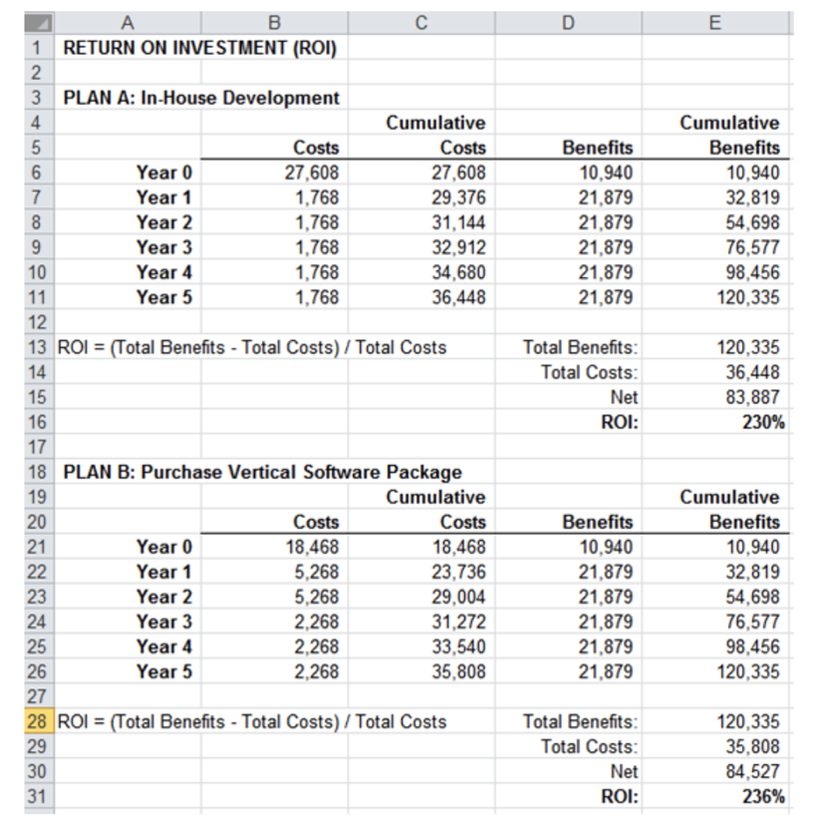

# **Systems Design**

## **User Interface Design**

The User Interface consists of hardware, software, screens, menus, functions, output, and features affecting two-way communication. Its ultimate purpose is increasing usability. In Figure 12, the patient registration portal can be viewed. It is very clear and easy to read. Everything that can be interacted with on the page is labeled. This makes it easier for new users to be able to easily navigate the new system and get the care they need. These can also be found on the proposed billing user interface. The system does a combination check, a validity check, batch controls existence checks, data type checks, range checks, and reasonableness checks.

**Figure 12**

*New Patient Registration Portal*

**Figure 13**

*Billing User Interface*

## **Control Features**

**Figure 14**

*Control Features*

Output Technologies:

* Internet Based information delivery
* Email
* Blogs
* Instant Messaging
* Wireless Devices
* Digital audio, images, and video

# **Data Design**

## **ERD Drawing and Relationships**

**Figure 15**

*ERD with Relationships*

# **Systems Architecture**

## **Floor Plan Topology**

**Figure 16**

*Proposed Floor Plan*

## **Physical vs. Logical**

The IT professional can better troubleshoot a physical topology. The logical Topology of the entire system which involves various switches that communicate wirelessly with the main server in the hierarchical pattern of network.

## **Wireless Network Analysis**

**Table 5**

Benefits and drawbacks of Wireless Networks

|  |  |
| --- | --- |
| **Benefits** | **Drawbacks** |
| Allows employees to work anywhere within the network | Bandwidth limitations |
| More flexible | Signals can be blocked by architecture |
| Easily updated to support more users. | Speeds can be slower |
| Easier to maintain/ Cleaner look | Some systems may not be equipped to handle wireless |

# **Systems Implementation**

## **Test Plan**

A test plan consists of detailed procedures that specify how and when the testing will be performed, who will participate, and what test data will be used. The scope of this testing is to inspect functional and non-functional requirements to make sure everything is functioning properly, make sure the system meets the requirements, and that it is user friendly. Testing will be done by both automated system and manually by a team of developers. It will be tested periodically during development, as well as during the testing stage. It will also be checked during routine maintenance. The system will be checked by Desk Checking, where groups of developers review the code for errors. Unit testing will also be used to look for execution errors. System Testing will also be used to make sure the system is equipped to handle valid and invalid data, verify all system components are integrated correctly, and confirm that the system can handle predicted and unpredicted volumes of data in a timely manner.

## **Training Plan**

The type of training I would recommend would be Vendor Training. If the system includes the purchase of software or hardware, then vendor-supplied training is one of the features you should include. Vendor training is the act of being trained by those who made the system. This training is often offered for free or for a nominal price that may be negotiated lower. This training would be conducted at the vendor’s site by experienced trainers who provide hands-on experience. The scope of this training is usually limited to the vendor’s standard package.

## **Changeover Strategy**

The cutover strategy I would recommend for New Century would be phased operation. This is because the organization wants to minimize disruption to its operations and ensure that the new system is fully tested and functional before full implementation. The phased operation allows for a structured and gradual implementation of the new system, which can help identify and resolve any issues early in the implementation process. It might be more expensive, but the benefits of a more controlled and less risky implementation process make it the ideal choice for New Century.